**Smart Health Emergency System: A Fuzzy Logic and Routing Based Clinical Support Platform**

232534

Muhammad Abdullah Younas

[232534@students.au.edu.pk](mailto:232534@students.au.edu.pk)

232553

Halima Hanif

[232553@students.au.edu.pk](mailto:232553@students.au.edu.pk)

232559

Areeb Sehr

[232559@students.au.edu.pk](mailto:232559@students.au.edu.pk)

233105

Malik Usama Arif

[233105@students.au.edu.pk](mailto:233105@students.au.edu.pk)

232543

Ayema Amir

[232543@students.au.edu.pk](mailto:232543@students.au.edu.pk)

# Introduction

# Hospitals frequently face critical challenges during high-demand periods, such as pandemics or natural disasters. These include delayed emergency responses, overcrowded emergency departments, and inefficient use of resources. To address these issues, we present the Smart Health Emergency System—an AI-powered platform that leverages fuzzy logic for intelligent patient triage and the A* algorithm for optimized ambulance routing. By automating decision-making and minimizing travel time, this system enhances the efficiency and responsiveness of emergency medical services.

# OBJECTIVE

* Develop a Clinical Decision Support System (CDSS) using fuzzy logic to triage patients based on vital signs and age.
* Implement A* algorithm-based ambulance routing using real-world road network data to optimize emergency transport.
* Visualize patient condition distributions, vitals, and risk levels through an interactive and accessible user interface.
* Provide healthcare professionals with a dynamic dashboard for patient tracking and decision support.

# Research Paper Summary

***An application of the A* algorithm on the ambulance routing***

This study tackles a critical issue in emergency medical services—getting ambulances to patients as fast as possible. Using the A* algorithm, researchers mapped out the shortest routes for ambulances in Shah Alam, Malaysia, within a 5 km radius of a local clinic (KKSA). The algorithm outperformed traditional methods by factoring in road networks and real-world constraints, ensuring response times stayed under 10 minutes. By testing the system on real data, they proved it could reliably find the quickest paths, like one route that trimmed the distance to just 2.5 km. The findings offer a practical way to boost EMS efficiency, potentially saving more lives. Next steps include scaling up the system for broader use.

***Application of A* algorithm in intelligent vehicle path***

***Planning***

The authors highlight the limitations of traditional A* algorithms, such as inefficient heuristic functions and excessive inflection points in planned paths. To address these issues, they propose an optimized heuristic function with a dynamic weight coefficient and integrate the Floyd algorithm to smooth paths and reduce redundant nodes. Simulation experiments in MATLAB demonstrate that the improved A* algorithm significantly decreases the number of search nodes and inflection points, enhancing both efficiency and path smoothness. The results validate the effectiveness of the proposed enhancements for real-world intelligent vehicle navigation. The study contributes to advancing path planning techniques in autonomous driving systems.

***Clinical Decision Support Systems for Triage in the Emergency Department using Intelligent Systems: a Review***

The paper reviews the use of Clinical Decision Support Systems (CDSS) powered by intelligent systems to enhance triage processes in Emergency Departments (EDs). Traditional triage methods often rely on subjective human judgment, which can lead to misclassification and delayed treatment. CDSS aim to improve this by leveraging artificial intelligence techniques such as logistic regression, decision trees, support vector machines, artificial neural networks, and fuzzy logic. These systems use input variables like age, vital signs, and presenting complaints to predict key outcomes such as mortality, ICU admission, and hospital length of stay. While CDSS have demonstrated improved decision-making and potential to optimize patient care, most systems remain unvalidated in real-world settings. Challenges include data quality, regional applicability, and clinician trust. The study emphasizes the need for broader clinical testing, seamless integration into hospital workflows, and training for medical personnel to effectively use these systems.

***A Fuzzy Logic Based Clinical Decision Support System for Emergency Services***

This study presents a fuzzy logic-based clinical decision support system (CDSS) designed to classify emergency department patients into three categories: discharge, service admission, or intensive care. Using nine vital parameters (e.g., blood pressure, Glasgow Coma Score) from 180 patients, the system achieved an accuracy of 83%, sensitivity of 87%, and specificity of 76.6% upon initial evaluation, improving to 92.3%, 95.6%, and 96% after a week. The system leverages trapezoidal membership functions and 20 expert-derived fuzzy rules to address triage limitations in overcrowded emergency settings. Results demonstrate its potential to reduce diagnostic delays and optimize resource allocation, though physicians retain final decision-making authority. Future work may expand parameter sets and refine rules for broader applicability.

# System Architecture

The Smart Health Emergency System is composed of two primary components:

***Fuzzy Logic Triage Engine***

**Inputs:** Temperature, Oxygen Saturation, Heart Rate, Systolic and Diastolic BP, Age.

**Outputs:** Triage level (Stable, Serious, Critical) and risk score.

Built using the skfuzzy library and a structured rule base.

***Ambulance Routing Module***

**Technologies:** osmnx, networkx, folium, geopy.

**Capabilities:**

* Geocoding addresses to coordinates.
* Constructing travel graphs with real road networks.
* Penalizing unsuitable paths for emergency vehicles.
* Finding fastest paths using the A* algorithm.
* Visual route display with markers and path lines.

# Methodology

This section outlines the approach used to develop and implement the Smart Health Emergency System, which integrates fuzzy logic for triage and A* pathfinding for ambulance routing. It is divided into three key components:

## **Triage Evaluation using Fuzzy Logic**

The fuzzy logic-based triage module is designed to evaluate the severity of a patient's condition using six vital parameters: temperature, oxygen saturation, heart rate, systolic blood pressure, diastolic blood pressure, and age.

**Input Representation:** Each parameter is mapped to a fuzzy set using trapezoidal or triangular membership functions. For instance, oxygen saturation has three categories: critical, serious, and normal. These functions help represent vague clinical thresholds effectively.

**Rule Base Construction:**There were total 729 (3^6)rules out of which we considered 529 because the rest were medically irrelevant or unrealistic combinations.

**Inference and Defuzzification:** The Mamdani inference system is used to evaluate input conditions and infer risk scores. The output is defuzzified to yield a final risk score between 0 and 100, which is used to categorize the patient as Stable, Serious, or Critical.

**Classification Outcome:** The system returns a visual indicator (green, orange, red) along with the numeric score for clinical decision support.

**Defined Ranges:**

Temperature(°F)**: Min:**80°F , **Max:** 112°F

Systolic Blood Pressure (mmHg): **Min:** 80 mmHg ,

**Max:** 180 mmHg

Diastolic Blood Pressure (mmHg): **Min:** 50 mmHg ,

**Max:** 120 mmHg

Heart Rate (bpm) : **Min:** 40 bpm , **Max:** 180 bpm

Oxygen Saturation (%): Min : 50%, Max 100%

Age (Months): **Min:** 0 months , **Max:** 1200 months

## **Ambulance Path Optimization using A* Algorithm**

This component aims to find the shortest and fastest route from the patient's location to a hospital using real-world road data.

**Data Source and Graph Construction:** Using osmnx, the road network around the patient and hospital is retrieved and transformed into a weighted graph where nodes represent intersections and edges represent roads.

**Geocoding:** Addresses are converted to geographic coordinates using OSM’s geocoding services.

**Penalty Application:** Roads like footpaths or residential alleys are penalized by increasing their travel time to avoid routing ambulances through suboptimal paths.

**Heuristic Design:** A heuristic function calculates the great-circle distance divided by the maximum observed speed on the graph to estimate travel time.

**Pathfinding:** The A* algorithm implemented via networkx computes the optimal path by minimizing total travel time, considering both actual and heuristic costs.

**Visualization:** The resulting route is rendered on an interactive Folium map with clearly marked origin, destination, and path.

## **User Interface Design & Data Handling**

To make the system accessible to non-technical users, an intuitive web-based interface is developed using Streamlit.

**Interface Layout:** The app features two main tabs — Patient Assessment and Emergency Route Planner. Forms are provided for inputting patient data and addresses.

**Styling:** A custom dark-themed CSS design improves readability and visual comfort for emergency use.

**Patient Record Management:** Data from assessed patients is stored in a CSV file and visualized in tabular and graphical forms (e.g., pie charts, bar graphs).

**Session State:** st.session_state is used to maintain data between user interactions, ensuring a smooth user experience.

**Dynamic Visuals:** Visual indicators for each patient’s status, risk score bar graphs, and condition distribution pie charts offer immediate insights to healthcare staff.

# implementation details

The system was implemented using Python and integrates multiple open-source libraries and frameworks for different functional layers. Below is a breakdown of each key component:

***Frontend Implementation***

**Framework Used:** Streamlit was chosen for its simplicity, reactivity, and ability to rapidly prototype interactive web apps.

**Design Elements:** The app features a custom dark-themed interface using embedded HTML/CSS. Interactive elements include input forms, buttons, and tabs.

**Tabs Layout:**

**Patient Assessment Tab:** Allows users to input vitals and receive an automated triage classification.

**Emergency Route Planner Tab:** Lets users input source and destination addresses to generate ambulance routes.

**Session Handling:** Utilizes st.session_state to manage patient data and preserve state across interactions.

***Backend Logic***

**Fuzzy Inference System:**

Implemented using simpful library defining fuzzy variables (inputs/outputs) and rule sets.

Uses trapezoidal and triangular membership functions tailored for each input (e.g., temperature, oxygen saturation).

The output risk score is categorized into "Stable", "Serious", or "Critical" states.

**Pathfinding Engine:**

Built using networkx and osmnx to extract road networks from OpenStreetMap.

A* algorithm computes the optimal route considering both travel distance and estimated speed.

Penalty multipliers are applied to edges with undesired road types (e.g., service roads, footways).

***Data Management***

**Storage:** Patient records are stored persistently in a local CSV file (triaged_patients.csv).

**Processing:** pandas is used to clean, label, and format patient data for display and analysis.

**CSV Operations:** Includes loading, appending new records, and clearing/resetting the file when needed.

***Visualization & Analytics***

**Risk Score Display:** Uses matplotlib to render horizontal bar charts showing patient risk scores in color-coded formats.

**Patient Status Summary:** Pie charts are generated to show the distribution of patients across triage categories.

**Map Interface:**

folium renders an interactive map with ambulance routes, patient locations, and hospital markers.

streamlit_folium is used to embed these maps directly into the Streamlit UI.

This detailed implementation ensures a cohesive system that combines clinical intelligence with real-time routing and visual analytics, all within an accessible and user-friendly interface.

# Results

Patients were categorized effectively into triage classes with numerical risk scores.

Ambulance routes were computed within a few seconds, offering clear visuals of the optimal path.

Historical records supported trend visualization and risk distribution analysis.

Visual tools such as pie charts, risk bars, and styled tables improved data interpretation.

|  |  |  |
| --- | --- | --- |
| **Feature** | | **Result** |
| Triage Accuracy | Consistent with defined rules | |
| Routing Speed | 2–4 seconds per route calculation | |
| UI Functionality | Responsive and intuitive | |
| Data Management | Reliable for small datasets (CSV) | |

# Conclusions

This project demonstrates that combining fuzzy logic for triage with A* pathfinding for transport planning can significantly improve emergency medical workflows. The Smart Health Emergency System acts as a robust clinical decision support tool with the potential to enhance hospital response strategies and reduce treatment delays.

# Future Work

Replace CSV file storage with a scalable database (e.g., PostgreSQL, Firebase).

Integrate real-time traffic data for dynamic route planning.

Expand triage logic to include symptoms, comorbidities, or live monitoring data.

Conduct real-world validation in clinical settings.

Introduce user authentication and data security layers.

# Refrences

1. A* Algorithm for Ambulance Routing in Shah Alam – Journal Source.
2. Optimized A* for Path Planning – IEEE Source.
3. CDSS for Emergency Triage – Springer Review.
4. Fuzzy Logic-Based Emergency CDSS – BMC Informatics.
5. **Johns Hopkins Medicine** & **Cleveland Clinic** for temperaturenorms(Sources: en.wikipedia.org, hopkinsmedicine.org, verywellhealth.com)
6. **Medscape** and **Medical News Today** for heart rate,BP,oxygen(Source: emedicine.medscape.com +5)
7. **NHS/Ridgmount, Physiopedia, Wikipedia** for SpO₂guidelines
8. **Verywell Health** for confirming SpO₂ thresholds and risk levels

**DashBoard:**

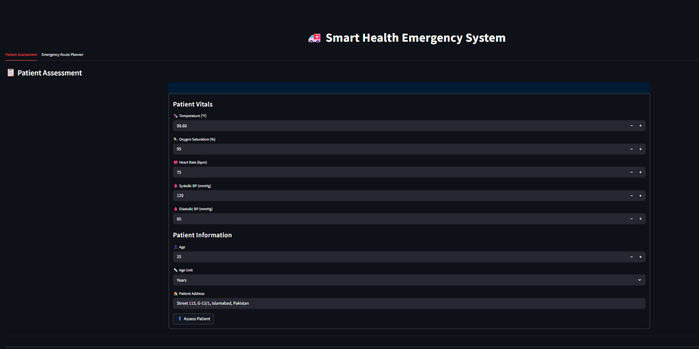

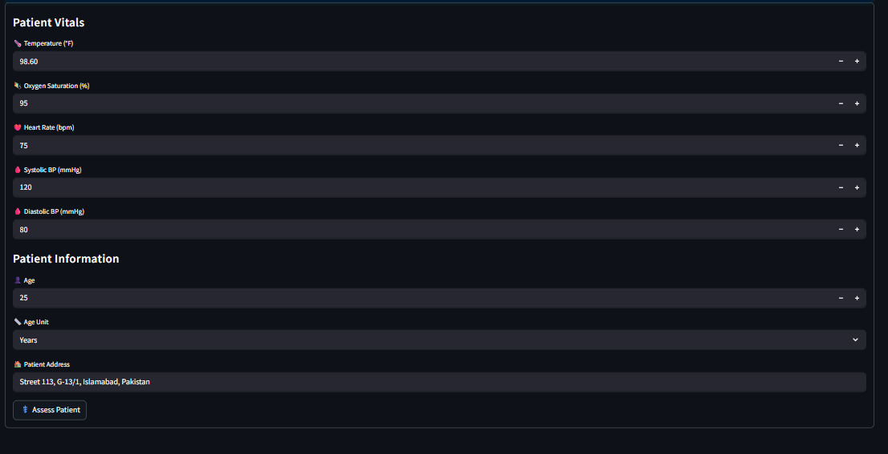

**Number of Patients and Avg Risk Score:**

**Horizontal Bar Chart:**

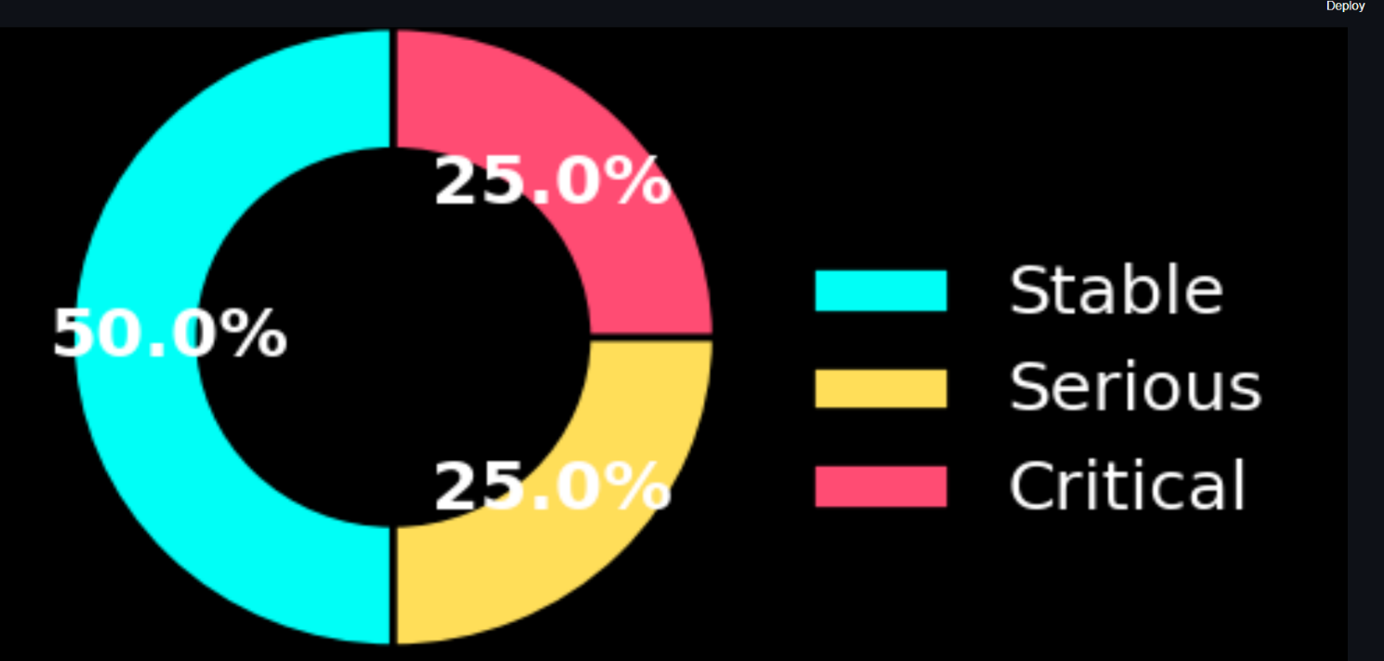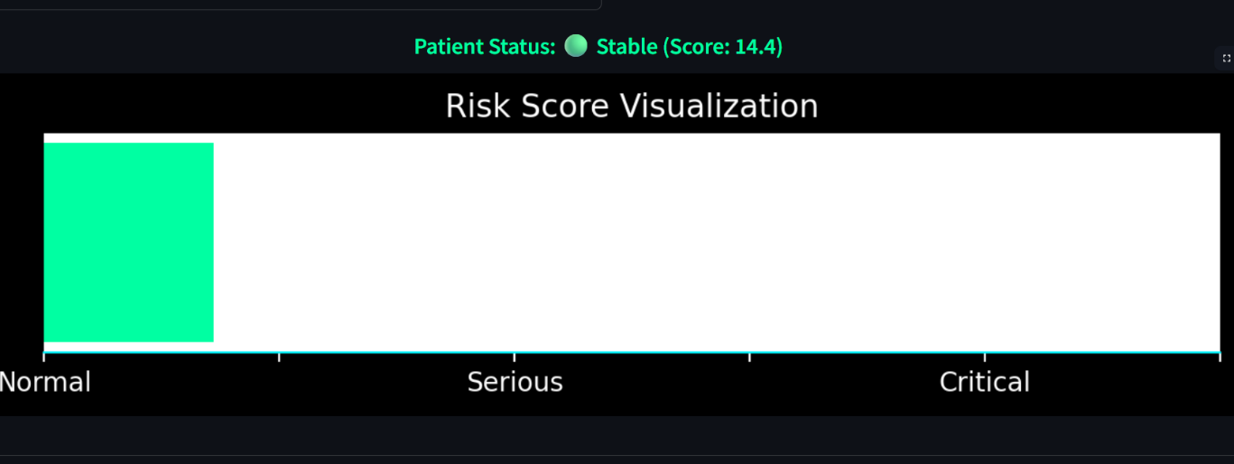**Donot Chart:**

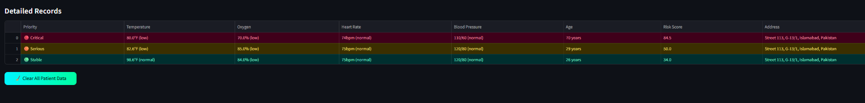**Detailed Records:**:

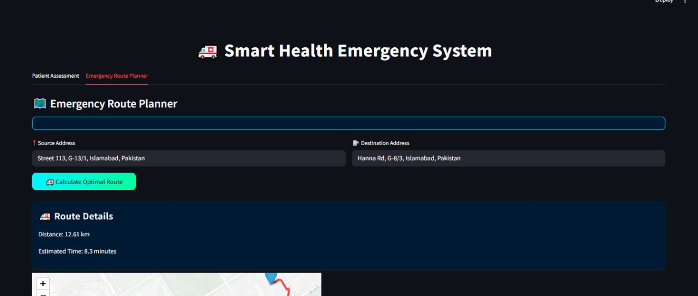**Emergency Route Plnaner:**

**Route Details:**

